**Project Report Format**

# 1. INTRODUCTION

## 1.1 Project Overview

This project aims to develop a deep learning–based system for automatic classification of fabric patterns. By analyzing images of fabrics, the model distinguishes between different pattern types (e.g., floral, geometric, abstract), providing valuable support for textile industries, e-commerce platforms, and design applications.

**1.2 Purpose**

The purpose of the project is to offer an efficient, accurate, and scalable tool for recognizing fabric patterns. Such automation improves cataloging, search, and inventory management in the textile domain and can enhance user experience in applications like fashion recommendation systems.

# 2. IDEATION PHASE

## 2.1 Problem Statement

## Manual classification of fabric patterns is time-consuming, subjective, and error-prone, particularly when dealing with large-scale inventories. An automated solution using deep learning can ensure consistent, fast, and reliable classification, reducing human effort and operational costs.

## 2.2 Empathy Map Canvas

## The empathy map focuses on stakeholders like textile manufacturers, retailers, and online shoppers who:

## Think & Feel: Frustration over manual categorization, desire for modern solutions

## See: Rapidly changing fashion trends, diverse pattern types

## Say & Do: Complain about inefficiencies, seek automation

## Pain: Time-intensive labeling, inconsistent categorization

## Gain: Faster operations, improved search and recommendations, better customer satisfaction

## 2.3 Brainstorming

# Several approaches were considered:

# Classical image processing with feature extraction

# Conventional machine learning algorithms

# Deep learning with Convolutional Neural Networks (CNNs)

# After discussion, CNNs were chosen due to superior performance in image classification tasks.

# 3. REQUIREMENT ANALYSIS

**3.1 Customer Journey map**

## Identifies user touchpoints:

## Upload fabric images → classification by model → results displayed → pattern labels integrated into catalog or search system

## 3.2 Solution Requirement

**Functional Requirements:**

* Upload images via web UI
* Predict pattern class
* Display results to users
* Allow batch processing for datasets

**Non-Functional Requirements:**

* High classification accuracy (>90%)
* Low response time
* Scalable architecture for large datasets
* User-friendly interface

**3.3 Data Flow Diagram**

## Input: Fabric image

## Processing: Image pre-processing → deep learning model inference

## Output: Predicted pattern class displayed to user or stored in database

## 3.4 Technology Stack

* Front end: HTML, CSS, JavaScript
* Back end: Flask (Python)
* Model: Convolutional Neural Network (CNN)
* Storage: Local/Cloud storage for images and results
* Tools: TensorFlow/Keras, OpenCV, VS Code

# 4. PROJECT DESIGN

**4.1 Problem Solution Fit**

The solution matches the textile industry's need for efficient and reliable pattern classification, reducing manual efforts and errors.

**4.2 Proposed Solution**

A web-based application allowing users to upload fabric images and receive the predicted pattern class. Supports both single-image and batch processing.

**4.3 Solution Architecture**

# UI Layer: User inputs images via web page

# API Layer: Flask handles HTTP requests

# Model Layer: CNN processes images and outputs predictions

# Storage Layer: Stores uploaded images and classification results

# Output Layer: Displays pattern classes and confidence scores

# 5. PROJECT PLANNING & SCHEDULING

## Project Planning

# Project phases:

# Data collection & labeling

# Data preprocessing

# Model training & evaluation

# Web UI development

# Integration & deployment

# Testing & documentation

# Velocity tracked via agile sprints to monitor progress.

# 6. FUNCTIONAL AND PERFORMANCE TESTING

**6.1 Performance Testing**

# Measured model accuracy on test dataset

# Assessed inference time per image

# Conducted load testing for batch processing

# Evaluated model performance on different fabric types and lighting conditions

# 7. RESULTS

## 7.1 Output Screenshots

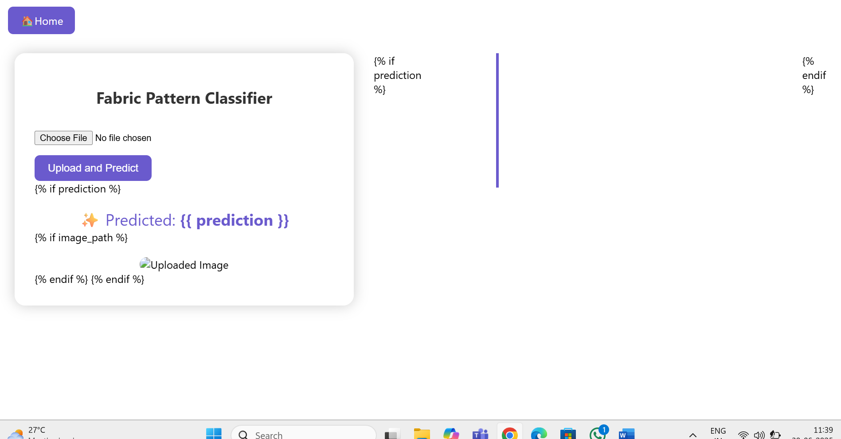

# 8. ADVANTAGES & DISADVANTAGES

**Advantages**:

* Reduces manual effort in pattern classification
* High accuracy and consistency
* Scalable for large datasets
* Supports integration with inventory or recommendation systems

**Disadvantages**:

* Requires sufficient labeled data for training
* Performance may vary on low-quality or highly similar patterns
* Initial development costs for model training and deployment

# 9. CONCLUSION

# The proposed system successfully classifies fabric patterns using deep learning, offering an automated, reliable, and scalable solution for textile and fashion industries. It improves operational efficiency and enhances user experience in digital applications.

# 10. FUTURE SCOPE

# Extend model to detect multiple patterns within a single fabric

# Add texture analysis for improved classification

# Develop mobile application for on-the-go pattern recognition

# Integrate recommendation engines for design suggestions based on detected patterns

# 11. APPENDIX

Source Code(if any)

Dataset Link

GitHub & Project Demo Link

<https://drive.google.com/file/d/1DUiZgHZF9BCZFVNOx8ZQ_uIKFlrNxipH/view?usp=sharing>

<https://github.com/rohitpechetti/Pattern-Sense-Classifying-Fabric-Patterns-using-Deep-Learning/tree/main/Sourcecode>

<https://drive.google.com/file/d/1xR4Utxb47xHN1pEJcBKWQ3HGsEQ94kcr/view?usp=sharing>